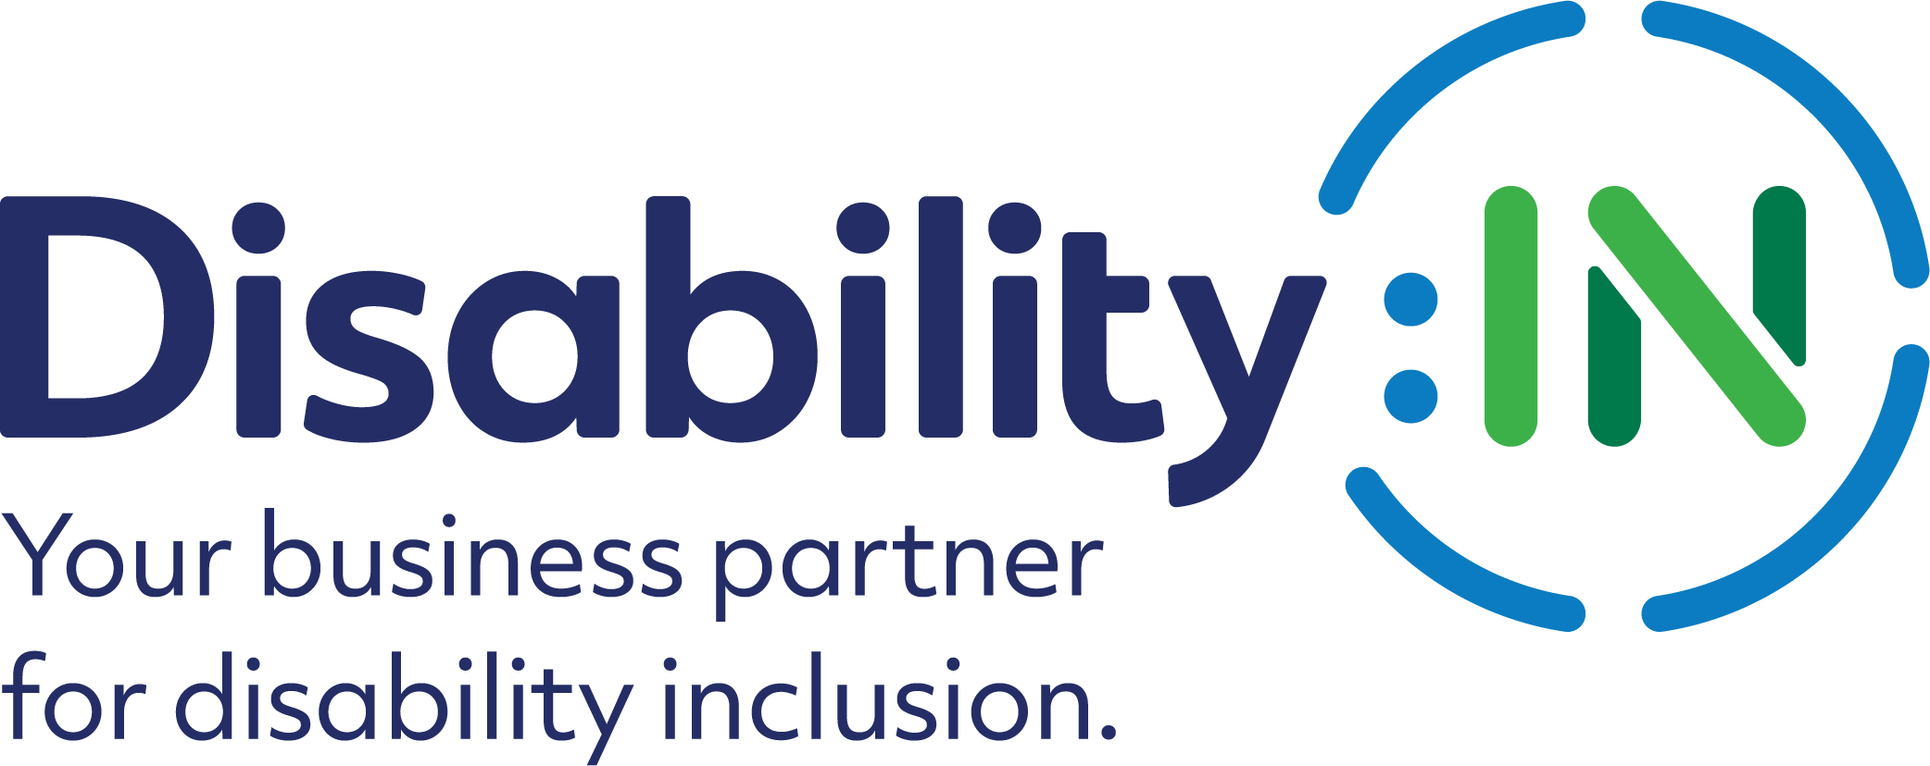

Disability:IN APAC Virtual Disability Recruiting Showcase

GOAL OF THE APAC VIRTUAL DISABILITY RECRUTING SHOWCASE:
The Showcase goal is to assist corporations to connect with college students, recent graduates, early, mid-level, and experienced talent with disabilities in Australia, India, Japan, Singapore, the Philippines, and Taiwan for employment, apprenticeship, and internship opportunities.

For more information, please contact Bridgette Anderson: Bridgette@Disabilityin.org

Title: Disability:IN APAC Virtual Disability Recruiting Showcase
When: November 29, 2022
Time: Total 7 hours to account for differing time zones. See chart below. Registered college students/candidates may participate in as many recruiting rooms as they desire.
APAC Virtual Disability Recruiting Showcase, November 29, 2022
Graph Outlining Times of Each Country’s Time Slot
2 Countries Recruiting Rooms in 1st Time Slot Running Concurrently
11/29 | Taiwan | 9:00– 11:00 AM CST
11/29 | Japan | 10:00 AM -12:00 PM JST
2 Countries Recruiting Rooms in 2nd Time Slot Running Concurrently
11/29 | Australia | 2:30-4:30 PM AEDT
11/29 | Singapore | 11:30 AM -1:30 PM SGT
2 Countries Recruiting Rooms in 3rd Time Slot Running Concurrently
11/29 | India | 11:30 am – 1:30 PM IST
11/29 | The Philippines | 2:00-4:00 PM PHST

Candidates: College students, recent college graduates, early, mid-level, and experienced candidates with disabilities. Candidates are required to submit an up-to-date resume and complete a registration form.
Registration Link: https://disin.swoogo.com/APACRecruiting2022

Deadline: Candidate registration deadline is November 22, 2022.
Accommodations: Sign language interpreting, appropriate to the selected countries,
CART (live captioning which will appear on the screen in English), and links to captioning in up to 30 languages.

Companies: Participating multi-national companies with internship,
apprenticeship, and employment opportunities will be announced.
Format: One room for each country (6 total) to run two (2) at a time concurrently: Eight (8) corporate recruiters representing (8) different multi-national companies will present their companies’ overviews and employment, apprenticeship & internship opportunities. The last 30 minutes will be live Q&A and dialogue with the participating candidates via the chat function.

Virtual Platform: Zoom
Content: Each company will present to college students/candidates over 90 minutes:
- Introduction of representative(s) and their role(s)
- A brief overview of their company and commitment to disability inclusion
- Available employment, apprenticeship, and internship opportunities:
- Eligibility
- Location of roles, range of positions, etc.
- Where/how to find employment opportunities
- Interview best practices
- The selection process

Resumes: All college students/candidates must provide a current resume to participate in the Showcase. Resumes will be received and reviewed by Disability:IN’s talent acquisition team, sent to participating companies on a weekly basis prior to the Showcase, and added to Disability:IN’s Resume Database.

Vetting: All college students/candidates will be vetted by Disability:IN’s Talent Acquisition team to ensure they meet the criteria for participation and are college students, recent graduates and early, mid-level, and experienced talent with disabilities.

Follow-up: Following the event, candidates will have access to Disability:IN’s Opportunities Page that will provide participating and non-participating company details. Companies and candidates will also be able to continue to express their interest in each other through LinkedIn, direct email, & the Disability:IN Resume Database.

Resume Database: Disability:IN’s Resume database serves as a talent resource for our Corporate Partners to use when searching for qualified candidates with disabilities. Resumes are regularly added to the database through events, our NextGen Leaders program and candidate outreach.

